Name of Student: HARPAL BIDAWAT | PRN:25070122080
Semester: III | Year : AY 2026-27
Subject: Programming with Java
ASSIGNMENT No :
TITLE : JDBC DriverManager, Connection, and Statement
Problem Statement
Demonstration and exploration of JDBC classes and interfaces (DriverManager, Connection, Statement).
Learning Objectives
To understand and use the core JDBC classes for database connectivity.

Programme
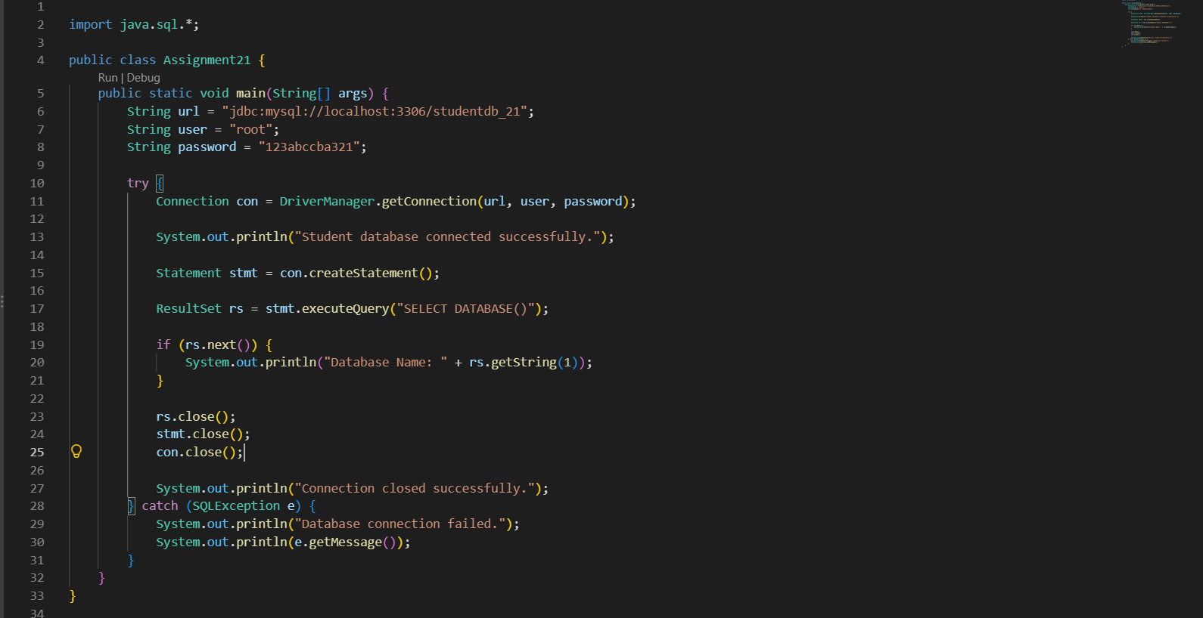
Output
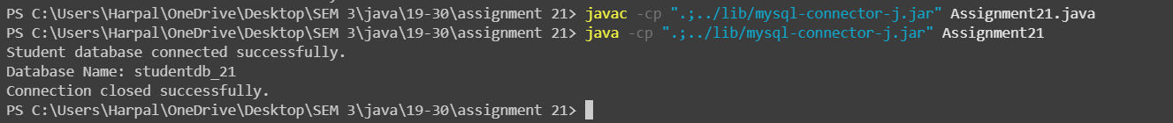
Conclusion

The program demonstrates JDBC connectivity using DriverManager, Connection, and Statement. It successfully connects to MySQL, executes an SQL query, displays the database name, and closes the connection.

